Project Proposal

SoulJournal

-inner journey-

Alexandru Georgescu , 23124091, [x23124091@student.ncirl.ie](mailto:x23124091@student.ncirl.ie)

Higher Diploma in Science in Computing

Specialisation (**Software Systems**)

10/06/2024

# Objectives

Our main objective is to provide a holistic journaling experience that supports mental wellbeing and personal growth. With a user-friendly interface, motivational quotes, and secure storage, SoulJournal will be your mindful companion for self-reflection and personal development.

As from our current

**The** **objectives**:

* Create a digital journaling application with a clean and minimalist design, adhering to principles of flat design, negative space and a limited colour palette.
* Add the Zen Quotes API/implement the API in that will generate inspirational quotes by analysing the mood of the user regarding its entry.
* Promote self-reflection and mindfulness through journaling prompts

# Background

Journaling has been a time-honored practice for self-expression, emotional processing, and personal growth. Studies have shown that by writing our thoughts and feelings on paper, participants would often reveal emotional trauma([***Jeremy Sutton, Ph.D)***](https://positivepsychology.com/benefits-of-journaling/). A well-known example is "***Meditations***" by ***Marcus*** ***Aurelius(***[***GoodReads)***](https://www.goodreads.com/book/show/30659.Meditations)*.*

In the past 30 years, studies have uncovered the benefits of putting pen to paper with your deepest thoughts and feelings. In a 2006 study, nearly 100 young adults were asked to spend 15 minutes journaling or drawing about a stressful event or writing about their plans for the day. The people who journaled saw the biggest reduction in symptoms like depression, anxiety and hostility.([***Kira M. Newman)***](https://greatergood.berkeley.edu/article/item/how_journaling_can_help_you_in_hard_times)As a fact, journaling is one of the most powerful and accessible self-improvement activities. It doesn’t require special knowledge and the costs are also minimal.(***[Kelsey Herbers](https://www.betterup.com/blog/how-to-start-journaling" \l "how-can-journaling-help-your-mental-well-being?)***)

As a person that has been journaling for the last 3 years, the benefits of it are the following:

* Increases your mindfulness
* It boosts creative thinking
* It helps you working on your self-improvement
* It can help improve your sleep

As there are many apps like the idea of **SoulJournal**, our goal is to create this app to help others by making journaling user-friendly and also accessible.

Our improvement would focus on enhancing the user experience to ensure that everyone can easily benefit from the therapeutic practice of journaling combined with the inspiration of personalized Zen quotes. We also aim to make **SoulJournal** a non-profit app to prioritize the well-being and personal growth of its users.

**Challenges** **in** **the** **traditional** **journaling (physical journal)**:

* Lack of motivation and consistency in writing practice.
* Difficulty finding inspiration for self-reflection.
* Limited accessibility of physical journals.
* Concerns over privacy and security of personal writings.

As a user of the physical journal, I can confirm that these challenges are present. When you write into a physical journal, even the smallest issue can put you off from writing:

* Misplaced the journal
* The ballpoint pen is consumed, hoping that you still have a spare one left
* When you’re writing into a physical journal, often you will end up with a foggy mind, as you don’t know what to write about, not having a template
* Always must be well stocked on the journals, being really picky about what journal would suit you (thick, thin, spiral, bullet point)
* As not living alone, you will always have the fear that someone will end up looking at your journal entries. That means that sometimes you may not be full sincere with your feelings as you’re afraid not to insult the person.
* And for every issue that delays your entry, there’s a study stating the fact that skipping something two days in a row may make you lose your momentum. Consistency is the key, but it is important when it comes to incorporating beneficial practices into our lives. ([***David Henzel****)*](https://www.managinghappiness.com/productivity/the-two-day-rule/)

Journal collection
**Journal Collection**

By addressing these challenges, **SoulJournal** seeks to create an engaging journaling experience that nurtures mental wellbeing and personal growth.

# Technical Approach

We have engaged with other competitors by testing their application. The following applications were tested:

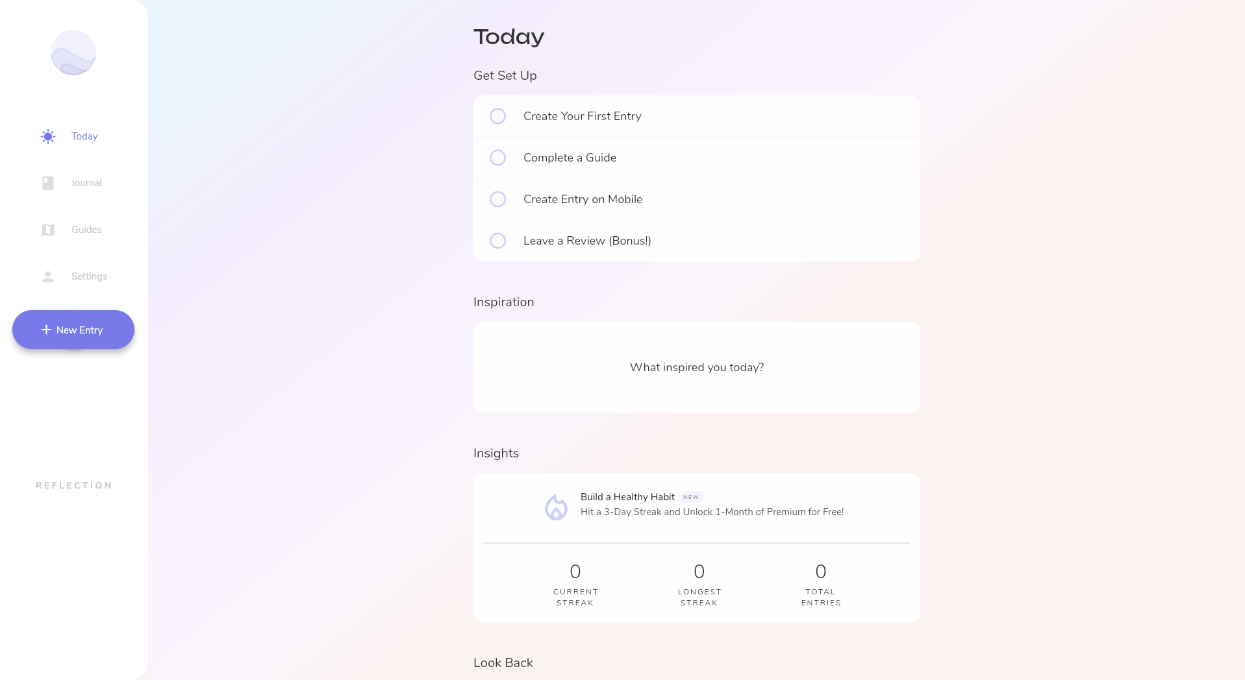**Reflection.app**

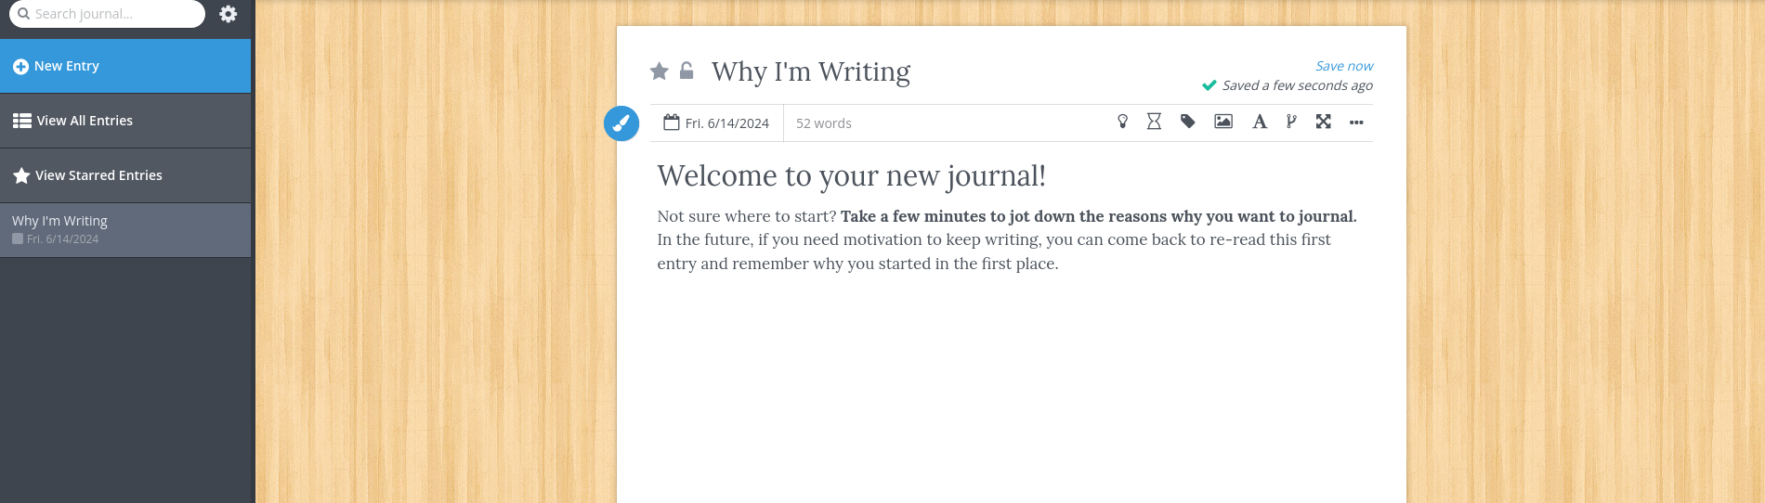

**Penzu.com**

As a result, we have come up to the conclusion that there is still place in the current market for another app, and even though there would be a similarity in the app that we’re implementing and the ones on the market, at the end of the day, is the user’s choice. As in cars, we have so many makes and models, and there are still some that make it to the top, even if they have features like others.

At the end of the day, our goal is to make the application thrive and reach the top of the market and helping the people.

In developing **SoulJournal**, we plan to follow an iterative and user-centered approach that incorporates research, requirements gathering, implementation, and testing.

**Research**:

* Analyse the benefits of journaling for mental health and personal growth.
* Explore existing journaling apps and their features.
* Understand user preferences and challenges with traditional journaling methods.
* Gather feedback on interface design and quote preferences.

**Requirements Capture**:

**Surveys:**

* **Target Audience:** We will look for potential users that could fall in the following classes:
  + - General Public
* **Areas to Explore:**
  + - **Journaling Habits:**
      * Frequency of journaling (daily, weekly)
      * Preferred time and duration for journaling sessions
      * Current journaling methods(digital/physical)
    - **Quote Preferences:**
      * Types of quotes that will match the mood
      * Length of quotes
      * Frequency of quote generation
    - **Features:**
      * Mood Tracking
      * Customization options (themes, fonts, layout)
    - **User Interface Design:**
      * Preferences for interface styles (minimalistic, colourful)
      * Text to Speech
    - **Non-Profit:**
      * Willingness to donate or support through non-monetary means

**Interviews:**

* **Target Audience:** We will select participants from people that have completed the survey and from users that already use journaling apps
* **Questions to ask:** 
  + **In-depth Journaling Experience:**
    - Personal experiences and benefits from journaling
    - Impact of quotes on journaling and mental well-being
  + **Features Feedback:**
    - Potential integrations
    - Specific feature suggestions and refinements
    - Preferences for notification settings and reminders
  + **User Interface and Experience**
    - Feedback on preliminary design layout
    - Suggestions for improvement

**Expected Outcomes**

* Understanding of user journaling habits and preferences
* Clear requirements for the types and frequency of quotes
* Identification of features and customizations

By fulfilling these tasks, we should be on the right path on ensuring the user needs are met and the application will stand out by being user-friendly, accessible and is genuinely focused on user well-being as a non-profit app.

**Implementation**:

* **Develop the Journaling Application.**
  + Build a responsive and dynamic user interface.
  + Implement the server-side logic.
  + Implement the database for storing user data, journal entries and configuration settings.
* **Integrate the ZenQuotes API.**
  + **Fetching Quotes**: Utilize the ZenQuotes API to fetch inspirational quotes.
  + **Customization**: Allow users to filter quotes by topics.
  + **Personalization:** Enhance the API by associating quotes with the user’s mood or recent entries using sentiment analysis.
* **Implement secure cloud storage for journal entries.**
  + **Encryption:** Ensure that all journal entries are encrypted before being stored in the databases to protect user privacy.
  + **Authentication:** Implement user authentication.
* **Develop User Interface.**
  + **Layout:** Create a clean and simple layout that focuses on the writing experience.
  + **Themes:** Offer themes for user preference

**Continuous Improvement**:

* **Regularly collect user feedback.**
  + Periodically send surveys and polls to users to gather feedback on new features and usability.
  + Provide an easy way for users to submit feedback directly w app, such as a suggestion box.
* **Periodically update the quote database with new material.**
  + Regularly add new quotes to the database to keep the content fresh and engaging for user.
  + Allow users to submit their favorite quotes, which can be reviewed and added to the database.
  + Introduce seasonal or thematic quote collections (**Mental Health Awareness)** to keep users motivated and inspired.

We hope that by following these strategies, SoulJournal can offer a unique, user-friendly and inspiring journalling experience.

# Special resources required

**Software**:

* Visual Studio Code (VSC) for coding.
* Github and Git for code management
* MongoDB for storing journal entries.
* Zen Quote API

# Project Plan

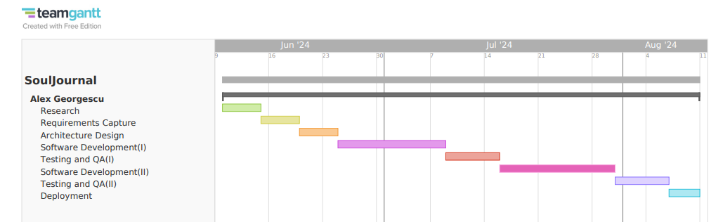

1. **Research**

Start Date: 10th June, 2024

End Date: 14th June, 2024

Duration: 5 days

1. **Requirements Capture**

Start Date: 15th June, 2024

End Date: 19th June, 2024

Duration: 5 days

1. **Architecture Design**

Start Date: 20th June, 2024

End Date: 24th June, 2024

Duration: 5 days

1. **Software Development (Iteration 1)**

Start Date: 25th June, 2024

End Date: 8th July, 2024

Duration: 14 days

1. **Software Development (Iteration 2)**

Start Date: 16th July, 2024

End Date: 30th July , 2024

Duration: 14 days

1. **Testing and Quality Assurance (Iteration 1)**

Start Date: 9th July, 2024

End Date: 15th July, 2024

Duration: 7 days

1. **Testing and Quality Assurance (Iteration 2)**

Start Date: 31st July, 2024

End Date: 6th August, 2024

Duration: 7 days

1. **Deployment**

Start Date: 7th August, 2024

End Date: 10th August, 2024

Duration: 4 days

# Technical Details

**Implementation** **Language** **and** **Libraries**:

**Languages:**

* JavaScript
* HTML/CSS
* SQL/NoSQL

**FrameWorks and Libraries**

* React
* Node.js
* MongoDB

# Evaluation

**Technical** **Evaluation**

The evaluation of **SoulJournal** will be conducted through technical testing and user evaluation to ensure the system’s functionality and usability.

**Technical Evaluation**

* **System Tests:** These tests will ensure that all components of our application work together.
  + **Functional Testing:**
    - Verify that all user actions (create an entry, retrieve quotes, save data) perform correctly.
    - Test all user interfaces to ensure they display correctly and respond to user actions as expected.
  + **Performance Testing:**
    - Measure the response time of the application under load conditions
    - Test all user interfaces to ensure they display correctly and respond to user actions as expected.
  + **Security Testing:**
    - Ensure that user data is securely encrypted and stored.
* **Integration Tests:** Integration tests will focus on the interactions between different components of **SoulJournal**, such as frontend, backend and external APIs.
  + **API Integration:**
    - Test the integration with the **ZenQuotes** API to ensure quotes are correctly fetched and displayed
  + **Database integration:**
    - Verify that data is correctly stored and in and retrieved from MongoDB
* **Unit Tests:** Unit tests will be written for individual components and functions.
  + **Component Testing:**
    - Test individual components to ensure they render correctly and handle state changes.
  + **Function Testing:**
    - Verify the functionality of components, such as the text editor and quote display.

#### **User Evaluation**

* **Task-Based Scenarios:** Conduct task-based scenarios where users perform specific tasks within the application. This will help identify usability issues and gather feedback on the overall user experience.

**Scenario Examples:**

* + Creating a new journal entry and adding tags.
  + Retrieving and saving a quote.
  + Customizing the journal's appearance (themes, fonts).
* **User Feedback Surveys:** Use surveys to gather quantitative and qualitative feedback from users. The surveys will include questions about the usability, design, and overall satisfaction with the app.
* **Survey Questions:**
  + How easy was it to create and save a journal entry?
  + How satisfied are you with the quote generation feature?
  + What features would you like to see added or improved?
  + How would you rate the overall design and layout of the application?
* **In-Depth Interviews:** Conduct in-depth interviews with a subset of users who completed the surveys. This will provide more detailed insights into their experiences and allow for follow-up on specific points of feedback.
* **Interview Focus:**
  + Discuss personal journaling habits and how **SoulJournal** fits into them.
  + Explore any challenges or frustrations encountered while using the app.
  + Gather suggestions for new features or improvements.

_____________________

Alexandru Georgescu / 10.06.2024